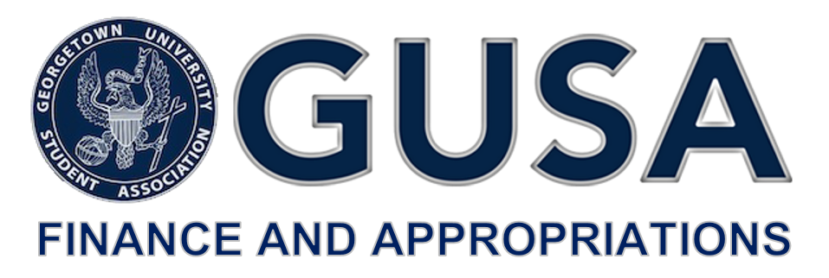

Dear Georgetown University Community,

This year, each Georgetown undergraduate will pay $164 for the student activities fee, resulting in a total of over $1,000,000 collected to fund student activities. The Finance and Appropriations Committee is a 13 member committee of GUSA Senators tasked with allocating this sum among those entities on campus that enrich the lives of undergraduate students beyond their academic endeavors.

The GUSA Finance and Appropriations Committee is pleased to announce the timeline for the annual budgeting and allocation of the Student Activities Fee.

The Advisory Boards (ABCS, CAB, CMSF, CSJ-ABSO, Media Board, PAAC, SAC), GPB, Lecture Fund and the GUSA Executive-Elect are invited to apply for funding for FY20. These entities are guaranteed time for a presentation at Budget Summit, provided an application is submitted.

Groups that do not fall within the aforementioned collective and are not supported by one of the Advisory Boards are eligible to submit an application for funding that will be reviewed by the Committee. If the application is accepted, the admitted entity will be assigned an Adjunct Committee Member to assist with any preparation leading up to the Summit.

The Committee is pleased to announce the timeline for the FY20 allocation cycle:

* Sunday, January 20th: the application for funding will be made available at 12:00 pm.
* Sunday, February 10th: the application for funding will be due at 11:59 pm. No applications will be accepted after this time.
* **Sunday, February 24th: Budget Summit will take place at 9am in the Leavey Program Room.**
* Committee deliberations and appeals will occur afterwards according to [GUSA bylaws section 9.03](https://docs.google.com/document/d/1bbNBkeSxhClrSgvCDhJuIItTwfE_ierPbMqo6aAlbiA/edit?usp=sharing) and the Committee’s spring availability. The exact dates and locations of deliberations and appeals will be made public no later than February 24th.

Office hours will be held for potential applicants throughout the duration of the application process. Liaisons are expected to meet with the leadership of their coverage entities to walk through this timeline, explain the application, and ensure that the full Committee is appropriately prepared to provide assistance to applicants.

The Committee looks forward to working with each applicant throughout this process. More details will be available when the Committee reconvenes in Spring 2019. Please direct any and all questions to [gusafinapp@georgetown.edu](mailto:gusafinapp@georgetown.edu), with Assistant Vice President for Student Affairs Erika Cohen Derr ([Erika.Cohen@georgetown.edu](mailto:Erika.Cohen@georgetown.edu)) and Director of the Center for Student Engagement Aysha Dos ([ad1578@georgetown.edu](mailto:ad1578@georgetown.edu)) cc’d.

Best regards,

Hayley Grande

Chair, GUSA Finance and Appropriations Committee